Using Bluetooth APP

iOS system:
- Open the APP store
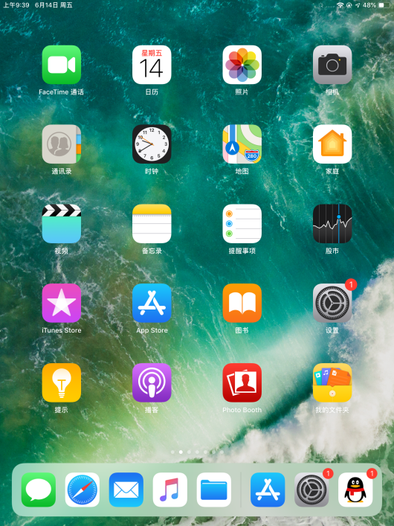

- Click to search keyestudio, and you will see the keyes BT car.
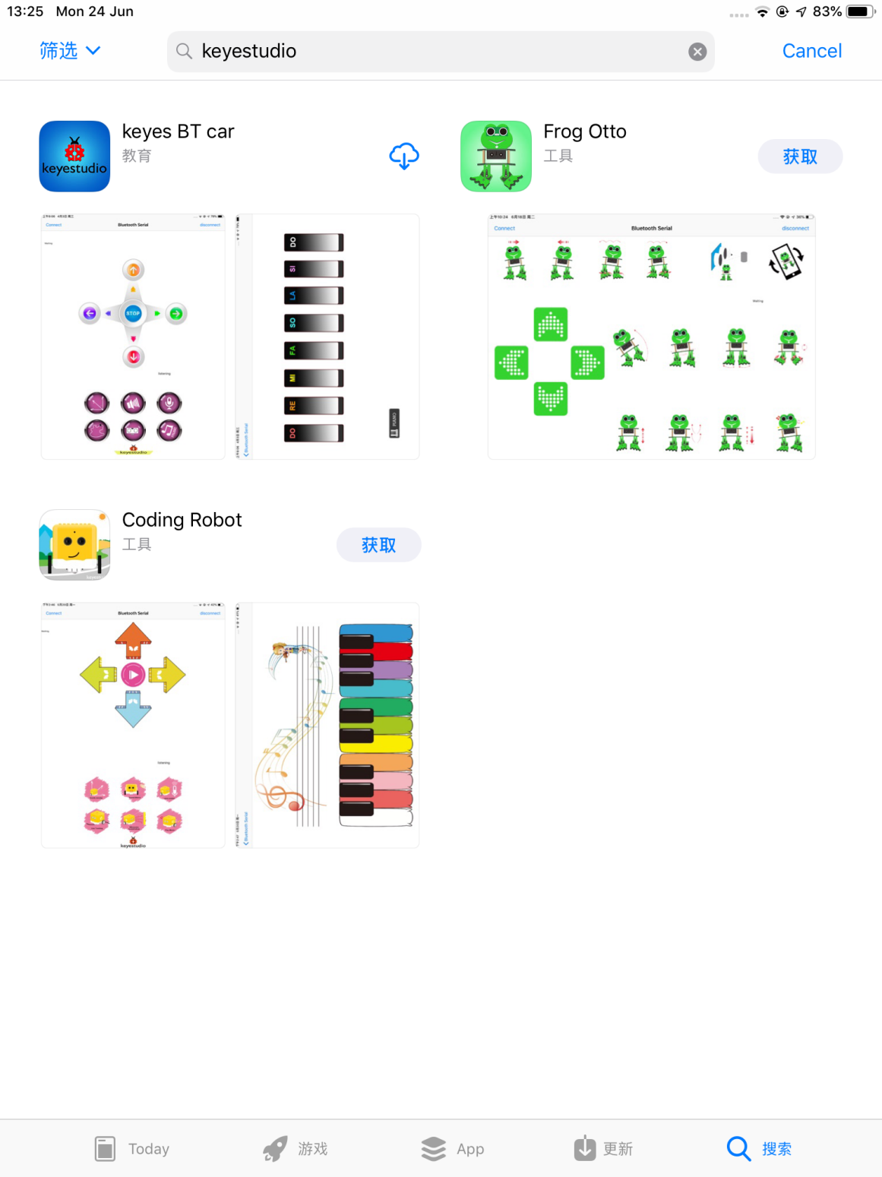

- Tap to open the keyes BT car
- To open Bluetooth, click the “Connect” on the upper left corner, searching and connecting Bluetooth.
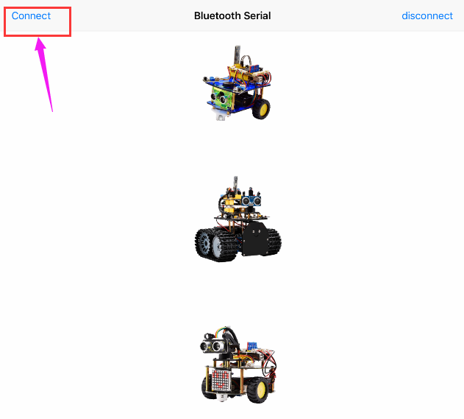

- Tap the Tank_Car icon to enter the control interface.
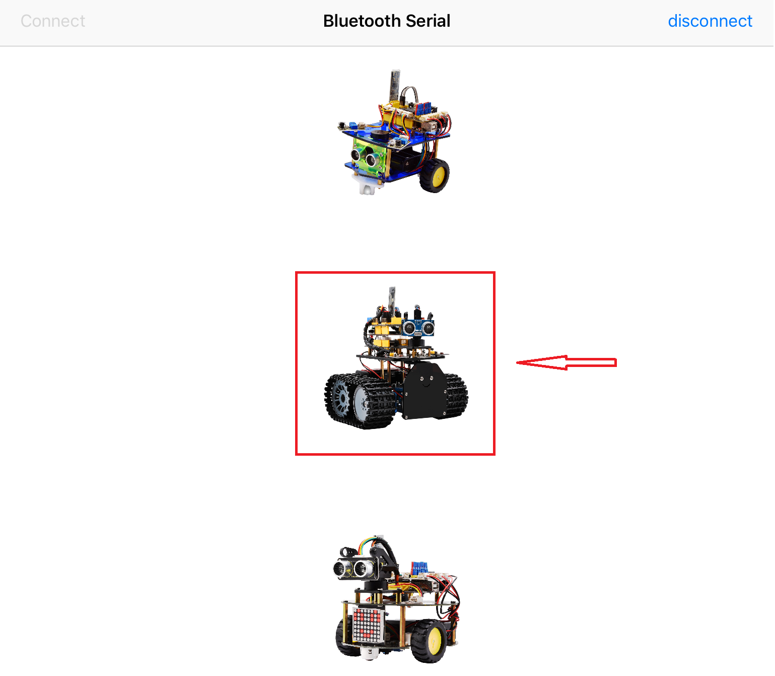
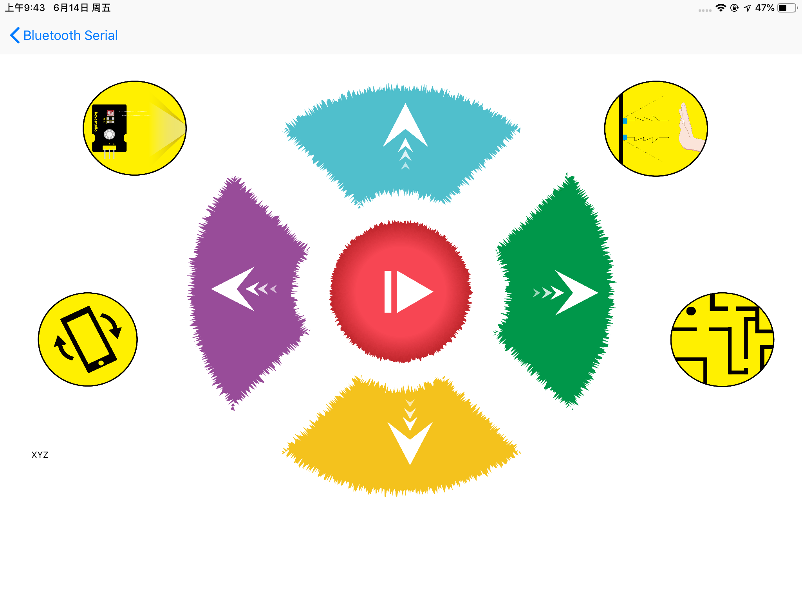

Below is Tank Robot Bluetooth APP interface and we have listed out what function of each key does:
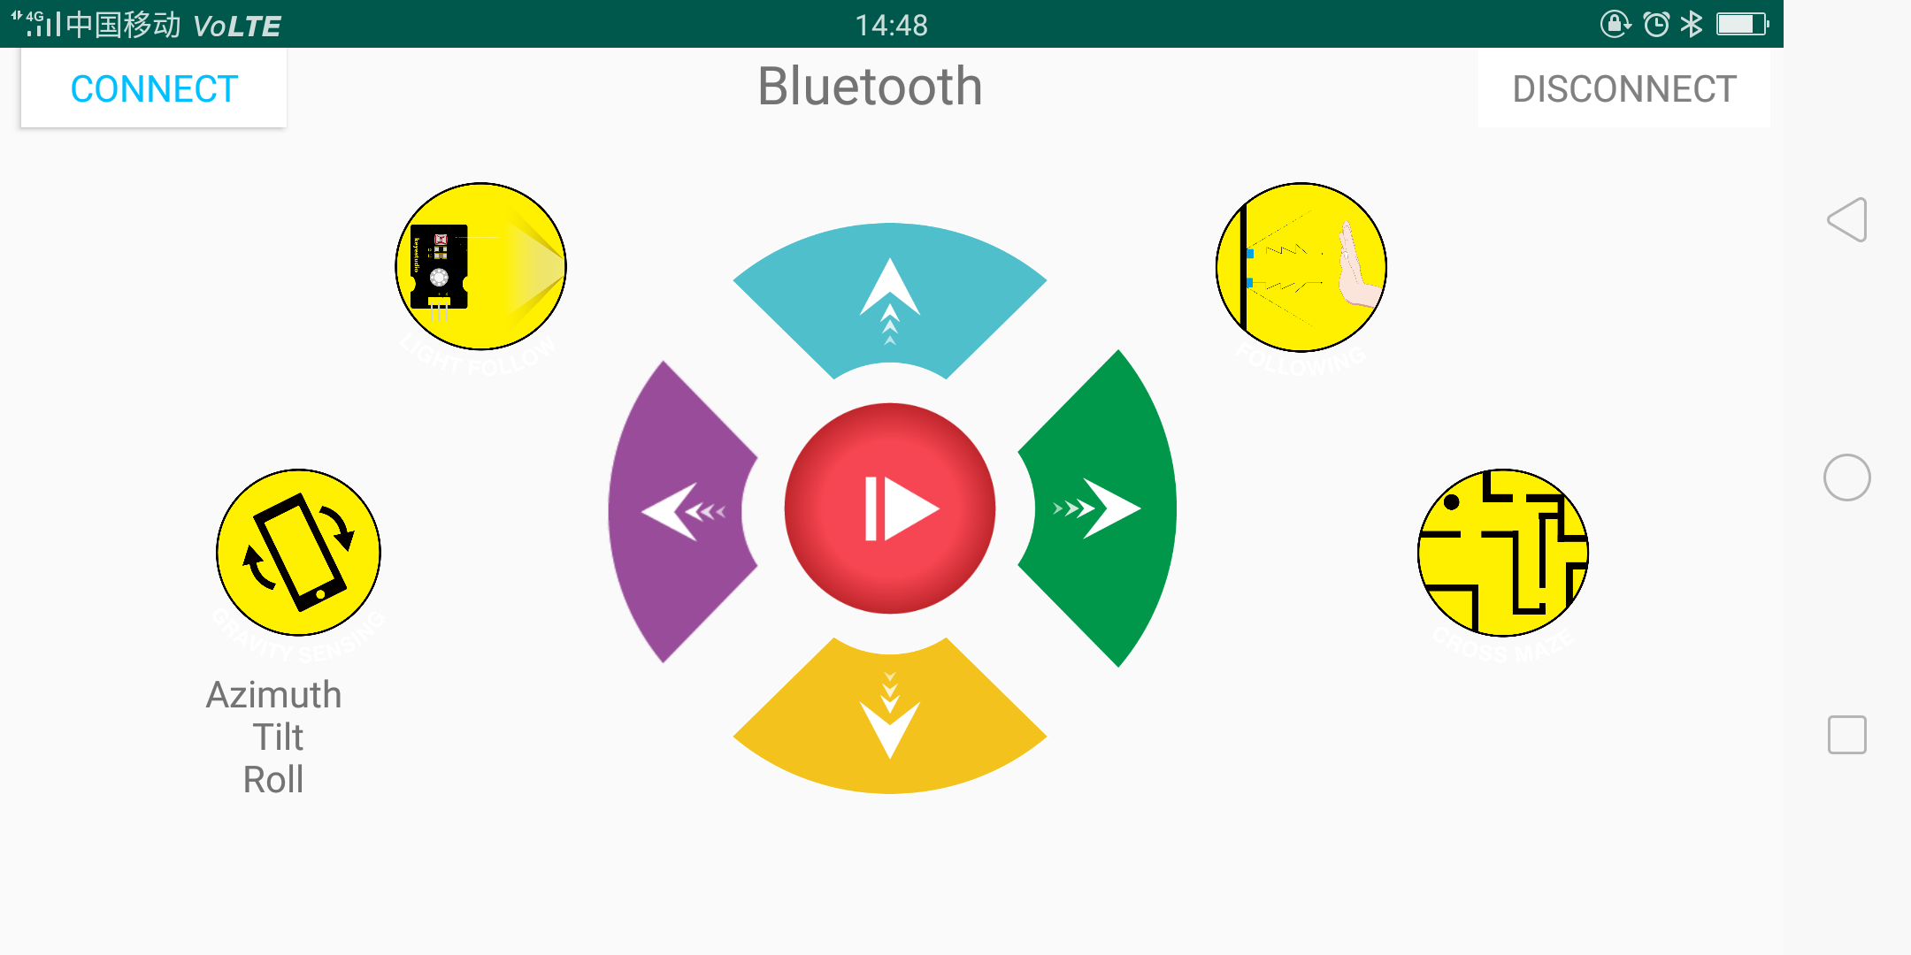
Button | Function
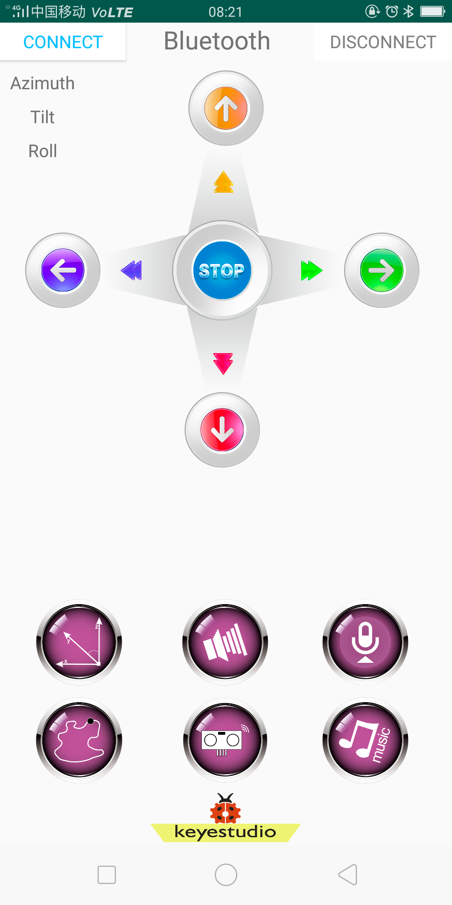 | pair and connect HM-10 Bluetooth module
 | enter Bluetooth control interface
 | disconnect the Bluetooth
 | Control character | Function
 | Press: F  Release: S | Press the button, robot goes front; release to stop
 | Press: B  Release: S | Press the button, robot goes back; release to stop
 | Press: L  Release: S | Press the button, robot rotates to left; release to stop
 | Press: R  Release: S | Press the button, robot rotates to right; release to stop
 | Click to send：S | Stop
 | Click to send “X” | Start light follow function; click Stop to exit
 | - | Click to start the mobile posture control; click again to exit
 | Click to send “Y” | Start ultrasonic follow function; click Stop to exit
 | Click to send “U” | Start ultrasonic avoiding function; click Stop to exit

